**Azure Virtual Desktop terminology**

**Agenda:**

Section 2:

1. [Host pools](https://learn.microsoft.com/en-us/azure/virtual-desktop/terminology#host-pools)
2. [Application groups](https://learn.microsoft.com/en-us/azure/virtual-desktop/terminology#application-groups)
3. [Workspaces](https://learn.microsoft.com/en-us/azure/virtual-desktop/terminology#workspaces)
4. [End users](https://learn.microsoft.com/en-us/azure/virtual-desktop/terminology#end-users)
5. [User sessions](https://learn.microsoft.com/en-us/azure/virtual-desktop/terminology#user-sessions)

Azure Virtual Desktop is a service that gives users easy and secure access to their virtualized desktops and applications. This topic will tell you a bit more about the terminology and general structure of Azure Virtual Desktop.

1. **Host pools:**

A host pool is a collection of Azure virtual machines that register to Azure Virtual Desktop as session hosts when you run the Azure Virtual Desktop agent. All session host virtual machines in a host pool should be sourced from the same image for a consistent user experience. You control the resources published to users through application groups.

Host pools are groups of virtual machines within Azure Virtual Desktop that share the same configuration, such as VM size, image, and other settings.

A host pool can be one of two types:

**Personal,** **Persistent** where each session host is assigned to an individual user. Personal host pools provide dedicated desktops to end-users that optimize environments for performance and data separation.

**Pooled,** **Non-Persistent** where user sessions can be load balanced to any session host in the host pool. There can be multiple different users on a single session host at the same time. Pooled host pools provide a shared remote experience to end-users, which ensures lower costs and greater efficiency.

**Purpose:** Host pools are used to manage and scale the deployment of virtual desktops in Azure. They help organize and distribute virtual desktops to users based on their requirements.

**Personal and pooled desktops:**

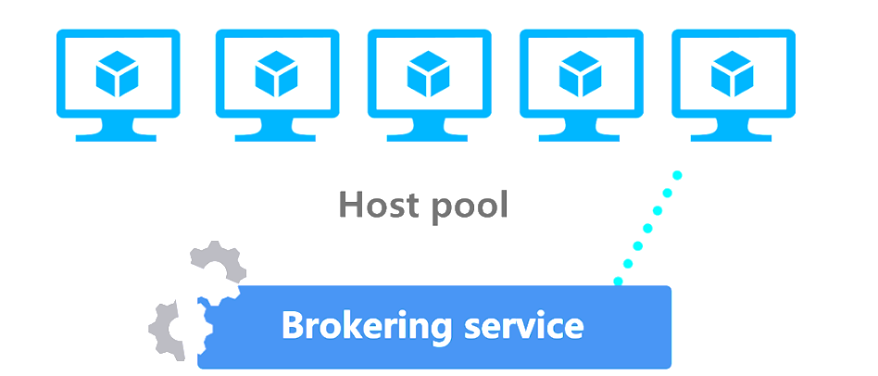Host pools are a collection of one or more identical virtual machines (VMs) within Azure Virtual Desktop environments.

Each host pool can contain an app group that users can interact with as they would on a physical desktop.

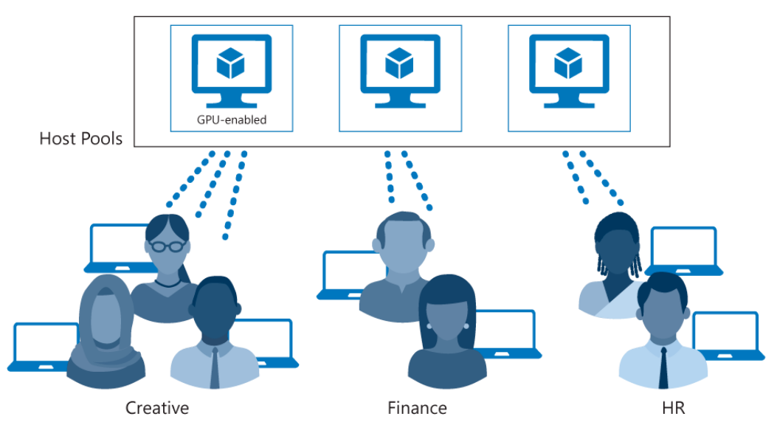

Users obtain access to host pools by being allocated to a host pool using an assigned Application Group:

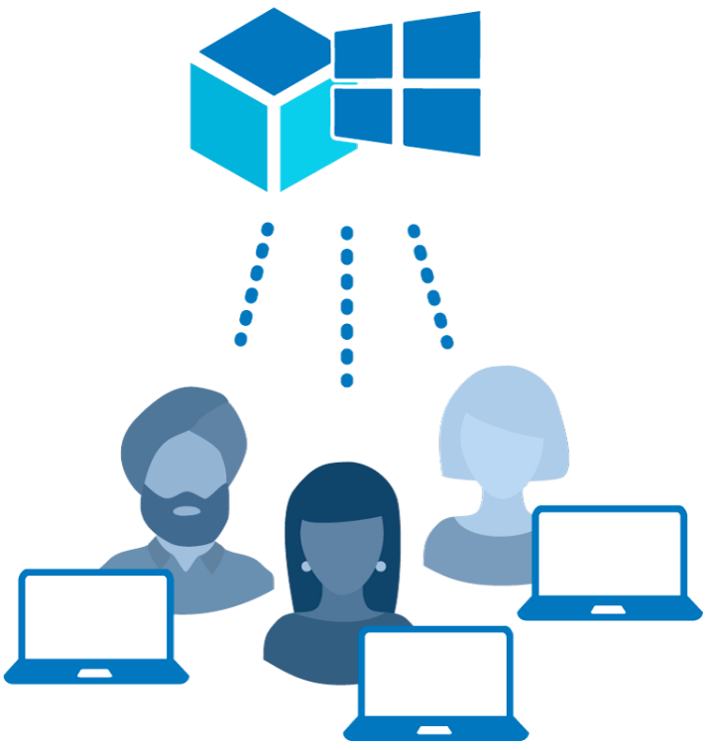**Pooled**: You can configure a pooled host pool for several users to sign in and share a VM. Typically, none of those users would be a local administrator on the pooled VM. With pooled, you can use one of the recommended images that includes Windows 10 Enterprise multisession. This operating system is exclusive to Azure Virtual Desktop. You can also use your own custom image.

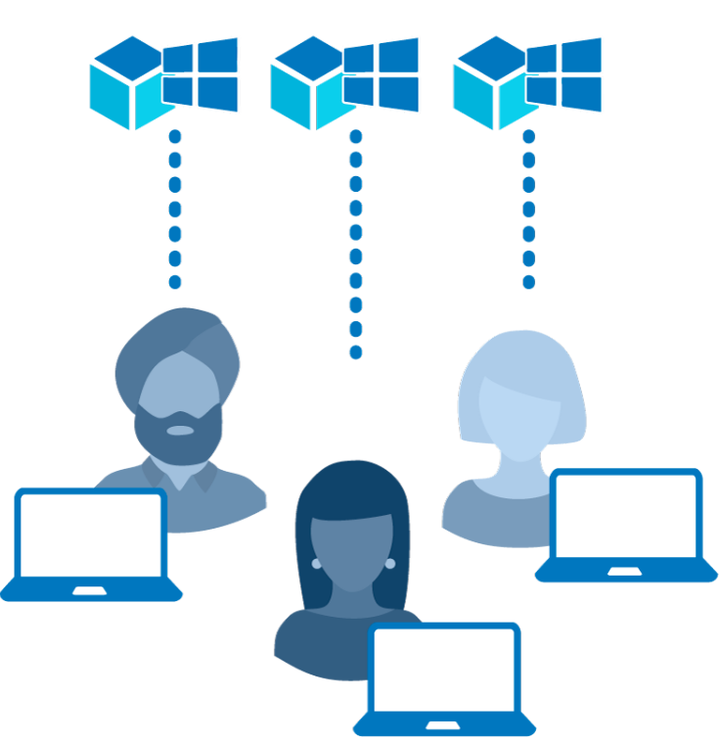**Personal**: A personal host pool is where each user has their own dedicated VM. Those users would typically be local administrators for the VM. This enables the user to install or uninstall apps without impacting other users.

Personal desktop solutions (sometimes called persistent desktops) allow users to always connect to the same specific session host. Users can typically modify their desktop experience to meet personal preferences, and save files in the desktop environment. Personal desktop solutions:

* Let users customize their desktop environment, including user-installed applications and saving files within the desktop environment.
* Allow assigning dedicated resources to a specific user, which can be helpful for some manufacturing or development use cases.

Pooled desktop solutions assign users to whichever session host is currently available, depending on the load-balancing algorithm. Because the users don't always return to the same session host each time they connect, they have limited ability to customize the desktop environment and don't usually have administrator access.

**Validation environment:**

You can set a host pool to be a [validation environment](https://learn.microsoft.com/en-us/azure/virtual-desktop/configure-validation-environment). Validation environments let you monitor service updates before the service applies them to your production or non-validation environment. Without a validation environment, you may not discover changes that introduce errors, which could result in downtime for users in your production environment.

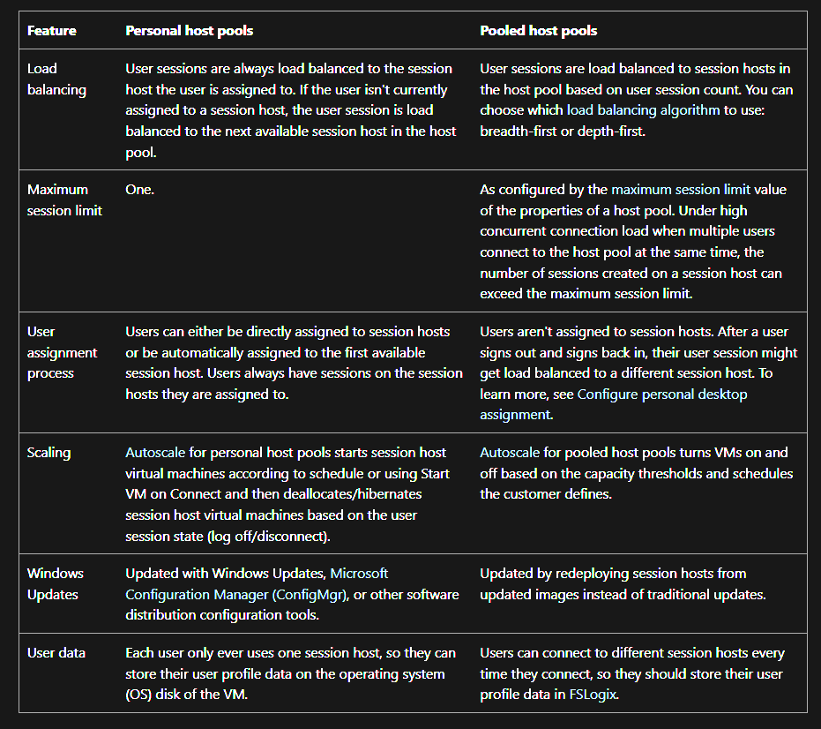To ensure your apps work with the latest updates, the validation environment should be as similar to host pools in your non-validation environment as possible. Users should connect as frequently to the validation environment as they do to the production environment. If you have automated testing on your host pool, you should include automated testing on the validation environment.

**Types of Non-Persistent virtual desktop:**

Single Session VDI :Session Host that allows only one interactive session per user

Multi Session VDI : Session Host that allows multiple concurrent interactive sessions for multiple users

**Balancing host pools:**

Azure Virtual Desktop supports two load-balancing methods. Each method determines which session host will host a user's session when they connect to a resource in a host pool.

The following load-balancing methods are available in Azure Virtual Desktop:

* Breadth-first load balancing allows you to evenly distribute user sessions across the session hosts in a host pool.
* Depth-first load balancing allows you to saturate a session host with user sessions in a host pool. Once the first session reaches its session limit threshold, the load balancer directs any new user connections to the next session host in the host pool until it reaches its limit, and so on.

Each host pool can only configure one type of load-balancing specific to it. However, both load-balancing methods share the following behaviors no matter which host pool they're in:

* If a user already has a session in the host pool and is reconnecting to that session, the load balancer will successfully redirect them to the session host with their existing session. This behavior applies even if that session host's AllowNewConnections property is set to False.
* If a user doesn't already have a session in the host pool, then the load balancer won't consider session hosts whose AllowNewConnections property is set to False during load balancing.

1. **Application groups:**

An [application group](https://learn.microsoft.com/en-us/azure/virtual-desktop/deploy-azure-virtual-desktop#create-an-application-group) is a logical grouping of applications installed on session hosts in the host pool.

An application group can be one of two types:

* RemoteApp, where users access the applications you individually select and publish to the application group. Available with pooled host pools only.
* Desktop, where users access the full desktop. Available with pooled or personal host pools.

Pooled host pools have a preferred application group type that dictates whether users see RemoteApp or Desktop apps in their feed if both resources have been published to the same user. By default, Azure Virtual Desktop automatically creates a Desktop application group with the friendly name **Default Desktop** whenever you create a host pool and sets the host pool's preferred application group type to **Desktop**. You can remove the Desktop application group at any time. If you want your users to only see applications in their feed, you should set the **preferred application group type** value to **RemoteApp**. If you want your users to only see session desktops in their feed, you should set the **preferred application group type** value to **Desktop**. You can't create another Desktop application group in a host pool while a Desktop application group exists.

To publish resources to users, you must assign them to application groups. When assigning users to application groups, consider the following things:

* We don't support assigning both the RemoteApp and desktop application groups in a single host pool to the same user. Doing so will cause a single user to have two user sessions in a single host pool. Users aren't supposed to have two active user sessions at the same time, as this can cause the following things to happen:
* The session hosts become overloaded
* Users get stuck when trying to login
* Connections won't work
* The screen turns black
* The application crashes
* Other negative effects on end-user experience and session performance
* A user can be assigned to multiple application groups within the same host pool, and their feed will be an accumulation of all application groups.
* Personal host pools only allow and support Desktop application groups.

**Purpose:** Application groups simplify application delivery to users by allowing administrators to define sets of applications that users can access without needing to deploy the entire desktop experience.

1. **Workspaces:**

A [workspace](https://learn.microsoft.com/en-us/azure/virtual-desktop/deploy-azure-virtual-desktop#create-a-workspace) is a logical grouping of application groups in Azure Virtual Desktop. Each Azure Virtual Desktop application group must be associated with a workspace for users to see the desktops and applications published to them.

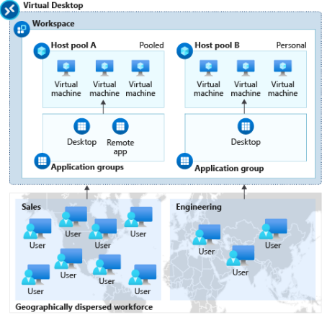

**Host pool A** has two application groups: Desktop and RemoteApp. These resources are shared (pooled) across the sales team.

**Host pool B** has a Desktop application group with personal desktops available to an engineering team

**Purpose:** Workspaces help organize and deliver a user's virtual desktop and applications, providing a seamless and customizable experience. Users can access their workspaces from various devices.

1. **End users:**

After you've assigned users to their application groups, they can connect to an Azure Virtual Desktop deployment with any of the Azure Virtual Desktop clients.

**Purpose:** End users are the beneficiaries of the virtual desktop infrastructure, accessing their work environment from various devices while benefiting from the flexibility, scalability, and security provided by Azure Virtual Desktop.

1. **User sessions:**

User sessions represent the active connections or sessions established by end users to access their virtual desktops and applications.

In this section, we'll go over each of the three types of user sessions that end users can have.

1. Active user session:

A user session is considered *active* when a user signs in and connects to their desktop or RemoteApp resource.

1. Disconnected user session:

A disconnected user session is an inactive session that the user hasn't signed out of yet. When a user closes the remote session window without signing out, the session becomes disconnected. When a user reconnects to their remote resources, they'll be redirected to their disconnected session on the session host they were working on. At this point, the disconnected session becomes an active session again.

1. Pending user session:

A pending user session is a placeholder session that reserves a spot on the load-balanced virtual machine for the user. Because the sign-in process can take anywhere from 30 seconds to five minutes depending on the user profile, this placeholder session ensures that the user won't be kicked out of their session if another user completes their sign-in process first.

**Purpose:** User sessions are a fundamental aspect of Azure Virtual Desktop's functionality, allowing users to interact with their virtualized environments in real-time. Monitoring and managing user sessions are crucial for optimizing performance and ensuring a smooth user experience.

1. **Load balancing:**

User sessions are load balanced to session hosts in the host pool based on user session count. You can choose which load balancing algorithm to use: breadth-first or depth-first

The choice between a breadth-first or depth-first deployment approach in the context of Azure AVD depends on your specific requirements and priorities. Let me explain the concepts and considerations for each approach.

1. **Breadth-First Deployment:**

* In a breadth-first deployment, you focus on rolling out the virtual desktop infrastructure to a large number of users or departments simultaneously.
* This approach is suitable when you have a wide range of users across different teams or departments who need access to Azure AVD.
* -It allows you to quickly provide a basic level of service to a large user base.

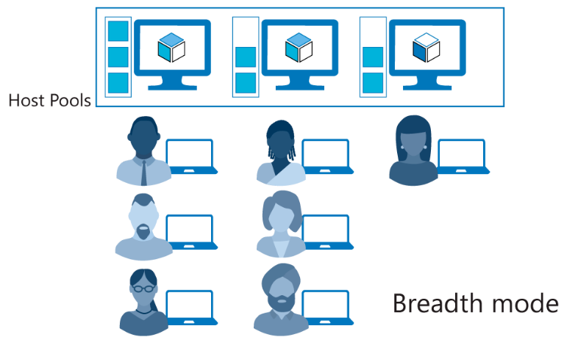

The breadth-first load-balancing method allows you to distribute user connections to optimize for this scenario. This method is ideal for organizations that want to provide the best experience for users connecting to their pooled virtual desktop environment.

The breadth-first method first queries session hosts that allow new connections. The method then selects a session host randomly from half the set of session hosts with the least number of sessions. For example, if there are nine machines with 11, 12, 13, 14, 15, 16, 17, 18, and 19 sessions, a new session you create won't automatically go to the first machine. Instead, it can go to any of the first five machines with the lowest number of sessions (11, 12, 13, 14, 15).

1. **Depth-First Deployment:**

* In a depth-first deployment, you prioritize providing a more comprehensive solution to a smaller group of users before expanding to other areas.
* This approach is beneficial when you have specific user groups or departments that have more complex requirements or need advanced features.
* 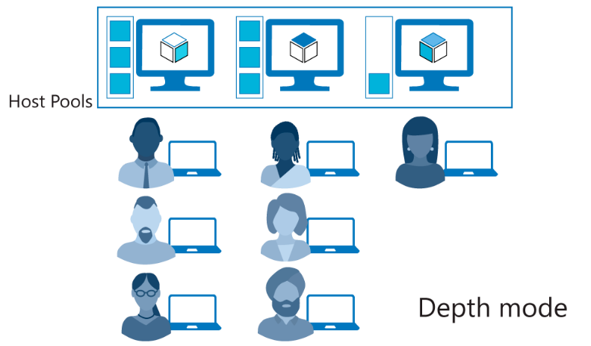It allows for in-depth customization, optimization, and testing before scaling up to a larger audience.
* The depth-first load-balancing method allows you to saturate one session host at a time to optimize for this scenario. This method is ideal for cost-conscious organizations that want more granular control on the number of virtual machines they've allocated for a host pool.
* The depth-first method first queries session hosts that allow new connections and haven't gone over their maximum session limit. The method then selects the session host with highest number of sessions. If there's a tie, the method selects the first session host in the query.
* The depth-first load-balancing algorithm distributes sessions to session hosts based on the maximum session host limit. This parameter is required when you use the depth-first load-balancing algorithm. For the best possible user experience, make sure to change the maximum session host limit parameter to a number that best suits your environment.

Considerations:

* User Requirements: Understand the unique requirements of your user base. If there are diverse needs across different departments, a breadth-first approach may be more appropriate. If certain groups have specialized needs, a depth-first approach may be better.
* Resource Availability: Consider the availability of resources such as IT support, training, and infrastructure. A depth-first approach may allow you to address issues more comprehensively before expanding.
* Pilot Programs: Conduct pilot programs with a small group of users to validate the infrastructure, address potential challenges, and gather feedback. This can be part of a depth-first strategy.
* Scalability: Assess the scalability requirements of your organization. If rapid scaling is essential, a breadth-first approach may be more suitable.

1. **FSLogix:**

The Azure Virtual Desktop service recommends FSLogix profile containers as a user profile solution